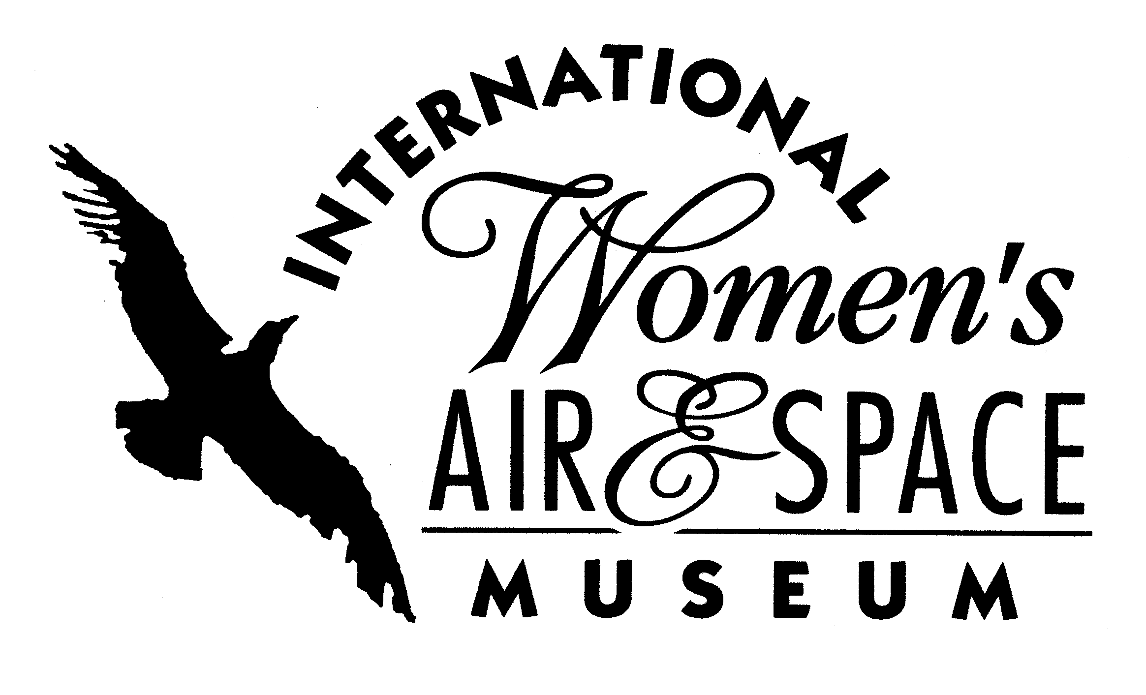
FOR IMMEDIATE RELEASE
January 7, 2009
Contact: Toni Mullee
216-623-1111
440-655-1514 (cell)
tmullee@iwasm.org
www.iwasm.org

Flight to Fame: The Life & Legacy of Amelia Earhart to open March 13, 2009
INTERNATIONAL WOMEN’S AIR & SPACE MUSEUM TO EXPLORE LIFE OF
AMELIA EARHART IN NEW EXHIBIT

On July 2, 1937 Amelia Earhart disappeared in her Lockheed Electra with her navigator, Fred Noonan, somewhere in the Pacific Ocean. They were never found. Over 70 years later the mystery of her disappearance and her legacy live on in the imaginations of people worldwide. The International Women’s Air & Space Museum will tell Earhart’s story through artifacts, narrative, and photographs in a new exhibit scheduled to run March 13, 2009 through September 13, 2009. Admission to the museum and the exhibit is free. The exhibit will look at her life in and out of aviation, her connection to Cleveland, her historic flights, the marketing of Amelia and her disappearance. The exhibit will also explore her lasting legacy in the aviation field. Rare artifacts in the museum’s collection will be on display, many for the first time, including a lock of Earhart’s hair, her nurse’s aid uniform from World War I and one of her flight suits. One of the most interesting items in the museum’s collection is a banner that was supposed to be given to Earhart prior to her flight to Howland Island by a representative of the Department of Interior. The instructions on the banner tell her to send it down from the plane if she’d like to get a message to Howland Island. For some reason the banner was never given to her. Could it have helped her alert searchers to her location?
Many of the women fliers featured in the museum’s permanent exhibits were Earhart’s contemporaries. Those exhibits will be updated with artifacts that reflect their relationships with her, including the museum’s exhibits on Ruth Nichols, Jackie Cochran, and Nancy Hopkins Tier.

-more-

AMELIA EARHART EXHIBIT OPENS MARCH 13, 2009 – p.2

Amelia Earhart was born in Atchison, Kansas in 1897. She was a nurse’s aid in Canada during World War I. She began flying in the early 1920’s and earned her pilot’s license in 1923. She became the first woman to fly across the Atlantic, as a passenger, in 1928. Earhart was dissatisfied with her role during the flight. She said, “I was just baggage, like a sack of potatoes.” But she became an instant celebrity, published a book about the flight, entitled “20 hrs. 40 min.” and toured the country. In 1932 she became the first woman to make a solo transatlantic flight and went on to set a number of records and “firsts”. In May 1937 Earhart began her round-the-world attempt. On July 2, 1937 she was scheduled to arrive on Howland Island, a small island located in the Pacific Ocean. Transmissions were received from her as she approached the island but she never arrived. Efforts to locate her plane were unsuccessful. Since that time there have been several theories about her disappearance and failed attempts to find her wreckage.
The International Women’s Air & Space Museum is located in the Burke Lakefront Airport terminal building, 1501 N. Marginal Road, Cleveland, OH. Museum admission is free and exhibits are open 8:00 am – 7:00 pm daily. The Fay Gillis Wells Research Center and Gift Shop are open Monday through Saturday, 10:00 am – 4:00 pm. Call (216) 623-1111 for more information or visit us on the web at www.iwasm.org.

For images of Amelia Earhart and museum artifacts visit www.iwasm.org/PressRoom.htm.

###
.

