
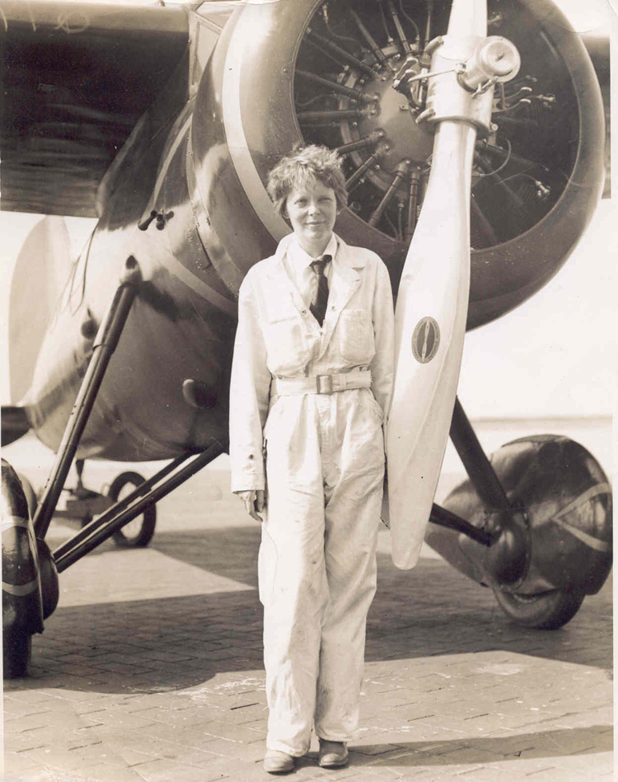

Flight to Fame: The Life & Legacy of Amelia Earhart

Exhibit Sponsorship - $2000

- Logo & link on IWASM website
- Logo included in all exhibit signage & marketing materials
- Company name included in all press releases, newsletter articles and enews blasts pertaining to exhibit
- Recognition in IWASM Quarterly newsletter
- Acknowledgement as exhibit sponsor at exhibit opening and all events related to exhibit, including Family Day & lecture series

Family Day Sponsorship - $1000

- Logo & link on IWASM website – Family Day page
- Logo included in Family Day signage & marketing materials
- Company name included in all press releases, newsletter articles and enews blasts pertaining to Family Day
- Recognition in IWASM Quarterly newsletter as Family Day sponsor
- Acknowledgement as Family Day sponsor at event

Lecture Series Sponsorship - $1000

- Logo & link on IWASM website – Lecture Series page
- Logo included in Lecture Series signage & marketing materials
- Company name included in all press releases, newsletter articles and enews blasts pertaining to Lecture Series
- Recognition in IWASM Quarterly newsletter as Lecture Series sponsor
- Acknowledgement as Lecture Series sponsor at event

Contributing Sponsorship

Contributing sponsors may choose to donate needed items (or make a cash-equivalent donation) for use in the exhibit or an event. This may include donations of food & beverage, volunteers and exhibit supplies. Contributing sponsors will be recognized on the IWASM website, in the IWASM quarterly and at the event to which their donation has been made.

Contributing Sponsorship Opportunities:

Refreshments for exhibit opening party $300 SOLD
Girl Scout giveaway for Family Day $500
Sponsor’s logo may appear on items

Exhibit opening mailing $250
Includes postcards and postage

Exhibit programming mailing $350
Includes postcards and postage

Exhibit panels $400 ea
Exhibit signage $350

Volunteer Opportunities:

Exhibit opening – member party 4 volunteers
Thursday, March 12, 2009
Family Day 4 volunteers
Saturday, March 14, 2009

Lecture Series 2 volunteers
Dates TBD

