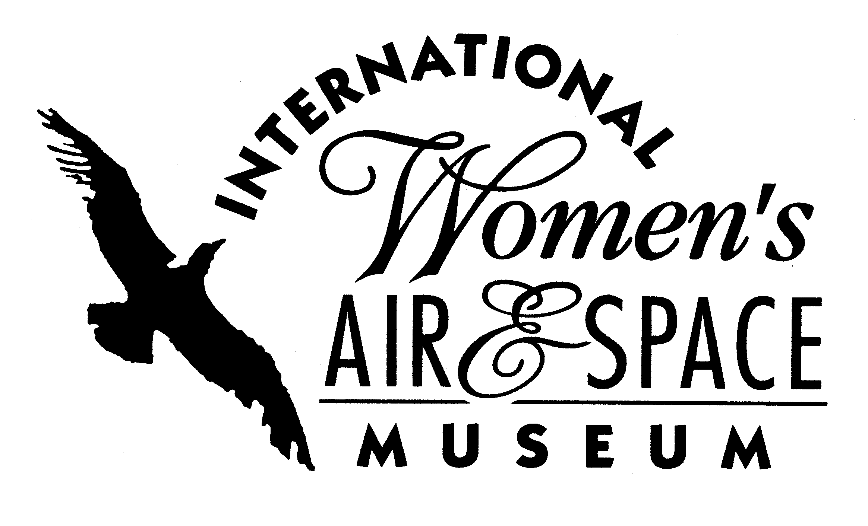

FOR IMMEDIATE RELEASE
July 29, 2008
Contact: Toni Mullee
216-623-1111
440-655-1514 (cell)
tmullee@iwasm.org
www.iwasm.org

First Woman F-22 Raptor Pilot To Be Special Guest at August 29, 2008 Event
INTERNATIONAL WOMEN’S AIR & SPACE MUSEUM TO HOST 3RD ANNUAL CORKS IN THE CONCOURSE PRE-AIR SHOW PARTY

The International Women’s Air & Space Museum (IWASM) is hosting its third annual Corks in the Concourse pre-air show party on Friday, August 29, 2008. This wine tasting event is held at the museum, which is located at Burke Lakefront Airport. All proceeds from the event will go directly to support IWASM. This year’s event features Ohio wines as Ohio wineries will be providing a sampling of their products throughout the evening. IWASM is pleased to announce that United States Air Force Captain Jammie “Trix” Jamieson, the first female F-22 Raptor pilot, will be a special guest at the event. Captain Jamieson is currently mobility Flight Commander for the 525th Fighter Squadron, 3rd Operations Group, 3rd Wing, Elmendorf Air Force Base, Alaska. The evening includes wine tastings, hors d’oeuvres, music provided by Gene’s Jazz Hot, jewelry sale, silent auction and live raffle. In addition, guests will enjoy a unique view of the air show planes in the airport’s grassy area overlooking the runway, which is opened up for the party.
Silent auction items this year include a hot air balloon ride for 2 or 4 people, the opportunity to be a Fighter Pilot for a Day, a Cuisinart wine cooler, aviation & space memorabilia, overnight stays at Maui Sands in Sandusky, the Intercontinental Hotel and the Marriott as well as numerous items donated by area attractions, restaurants, and organizations.
-more-

THIRD ANNUAL CORKS IN THE CONCOURSE, AUGUST 29, 2008 – p.2

A Lia Sophia representative will be on hand with jewelry for sale during the event. This high quality jewelry at affordable prices will be available for purchase with a portion of the proceeds going to the museum.
Tickets for the event are $55 for members and $60 for non-members. The ticket price include tastings, hors d’ouevres, a commemorative wine glass and parking. A designated driver ticket is available for only $35. Tickets can be purchased online at www.iwasm.org or by calling the museum office at 216-623-1111.
The International Women’s Air & Space Museum preserves the history of women in aviation and space by documenting their past, present and future contributions. The museum focuses its educational efforts on promoting careers in science, technology, engineering and mathematics (STEM) to students throughout Northeast Ohio.

The International Women’s Air & Space Museum is located in the Burke Lakefront Airport, 1501 North Marginal Rd. Museum admission is free and exhibits are open 8:00 am-8:00 pm daily. The Fay Gillis Wells Research Center and Gift Shop are open Monday through Saturday from 10:00 am to 4:00 pm. Call (216) 623-1111 for more information or visit us on the web at www.iwasm.org.
###

