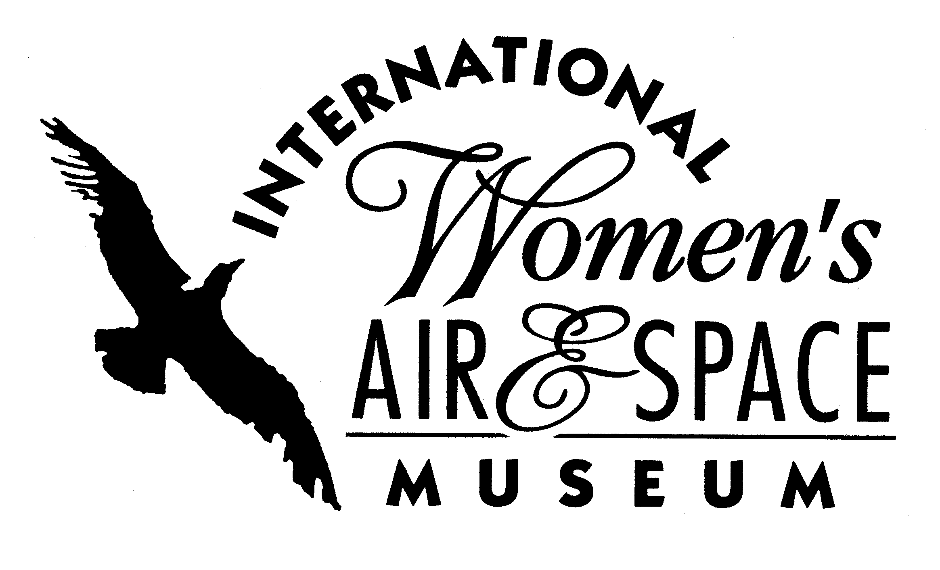
FOR IMMEDIATE RELEASE
April 28, 2007
Contact: Toni Mullee
216-623-1111
440-655-1514 (cell)
tmullee@iwasm.org
www.iwasm.org

TWO NEW EXHIBITS AT THE INTERNATIONAL WOMEN’S AIR & SPACE MUSEUM TO EXPLORE THE WORLD OF AEROBATIC FLYING

The International Women’s Air & Space Museum (IWASM) takes a closer look at the sport of aerobatic flying with two new exhibits open May 15 through September 5, 2007. Rock ‘N Barrel Rolls: Women in Aerobatics takes a trip through aviation history, highlighting women in aerobatics, from Ruth Law, the first woman to do the loop-the-loop, to Patty Wagstaff, three-time U.S. National Aerobatics Champion who still wows air show crowds today. The exhibit includes artifacts from Law, Wagstaff, Tracy Pilurs, Julie Clark and others.
Nancy Lynn: Inspiration Was Her Mission explores the life and career of Nancy Lynn, an aerobatic pilot who was a favorite on the air show circuit. Lynn died tragically in an air show accident in October 2006. The exhibit is the result of a collaboration between Lynn’s son, Peter Muntean, and this semester’s Public Relations Portfolio class at American University in Washington, DC.
Ruth Law bought her first plane, a Wright Flyer, in 1912. She was the first woman to do the loop-the-loop and in 1915 looped her plane an amazing sixteen times at a fair in Alabama. She was also the first woman to fly at night. Patty Wagstaff, who has performed at the Cleveland National Air Show, began pursuing aerobatic training in 1980, at the age of 30. Five years later she earned a spot on the US Aerobatic Team. Wagstaff won the US National Aerobatics Championships three times in a row. She broke barriers in the sport of aerobatics
-more-

AEROBATICS EXHIBITS OPENING AT IWASM – p.2

and opened doors for other women in the field. She has earned numerous awards and her airplane is on display at the National Air & Space Museum.
Nancy Lynn was a native of Dayton, Ohio who graduated from Denison University in Granville, Ohio. Lynn was employed by Proctor & Gamble in the 1980’s and became one of the company’s first women plant managers. She left Proctor & Gamble to pursue a love of flying, and became hooked on aerobatics. Lynn started performing in air shows in 1998 and participated in 10-12 shows a year. Lynn’s son, Peter, was her commentator and crew chief on the air show circuit. Her husband, Scott Muntean, died in 2001 from brain cancer and as a single
parent Lynn seriously considered giving up the sport of aerobatics. But her son encouraged her to continue doing what she loved. Lynn crashed while performing at a Virginia air show in October 2006 and died the next day from her injuries.
The International Women’s Air & Space Museum is located in the terminal building of Burke Lakefront Airport, 1501 N. Marginal Road. Museum admission is free. Exhibits are open daily 8:00 am – 8:00 pm. The Fay Gillis Wells Research Center and Gift Shop are open Monday through Friday 10:00 am – 4:00 pm and by appointment. For more information call the museum at 216-623-1111 or visit the website at www.iwasm.org.
###

Digital images are available in the museum’s press room at www.iwasm.org

