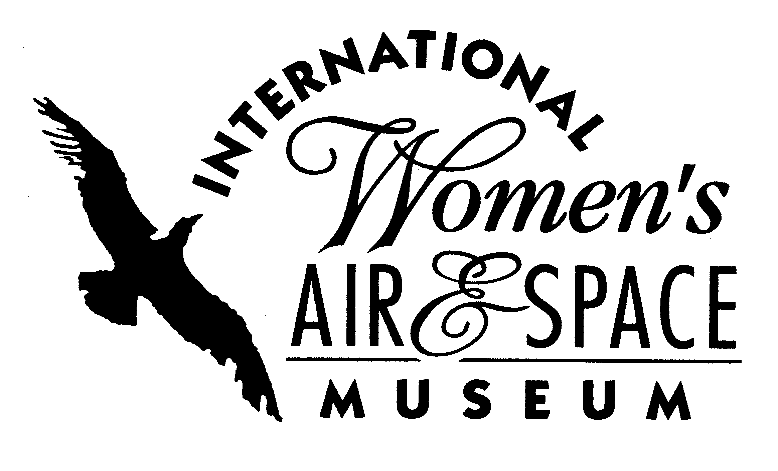
FOR IMMEDIATE RELEASE
May 6, 2009
Contact: Toni Mullee
216-623-1111
440-655-1514 (cell)
tmullee@iwasm.org
www.iwasm.org

APPLICATIONS STILL BEING ACCEPTED FOR SUMMER SCIENCE CAMPS

The International Women’s Air & Space Museum (IWASM) has extended the deadline for female high school students interested in applying for two summer camps sponsored by the museum. Applications are being accepted by the museum through May 22, 2009. Both camps are free for accepted participants and are funded by the Alcoa Foundation. Applications can be found at www.iwasm.org and www.clearedforliftoff.org. Students interested in this year’s camps are required to submit applications that include short essays, a transcript, and teacher recommendation.
Engineering Exploration Camp takes place June 28-July 1, 2009 for high school females on the campus of Ohio University in Athens, Ohio. The camp brings female high school students to the campus for several days of activities in various engineering disciplines. Scheduled are introductions to chemical, mechanical and industrial systems engineering as well as a tour of the Ohio University Airport. Students will complete projects during their stay on the OU campus. This year will be the third for the Nikki Kukwa Memorial Aviation Camp, which takes place on the campus of Kent State University July 12-14, 2009. The aviation camp is a unique mother-daughter experience. It is a 3-day visit to the Kent State campus in which high school students and their mothers live on campus together and have the opportunity to fly with university flight instructors. The campers also visit various aviation facilities throughout Greater Cleveland.
-more-

IWASM HOSTS SUMMER CAMPS FOR FEMALES INTERESTED IN ENGINEERING, AVIATION – p.2

IWASM’s focus on Science, Technology, Engineering and Mathematics (STEM) careers comes at a time when the United States still has the most science majors in the world but it ranks 25th when that number is adjusted for population. In U.S. schools, science has taken a backseat
to mathematics and language arts. Elementary school students spend an average of 16 minutes a day on science. According to the National Science Foundation women hold under one quarter of the science in the United States, with a meager 10% of engineering jobs currently being done by women.

The International Women’s Air & Space Museum is located in the Burke Lakefront Airport terminal building, 1501 N. Marginal Road. Museum admission is free and exhibits are open 8:00 am – 7:00 pm daily. The Fay Gillis Wells Research Center and Gift Shop are open 10:00 am – 4:00 pm Monday through Saturday. Call (216) 623-1111 for more information or visit us on the web at www.iwasm.org.

###

