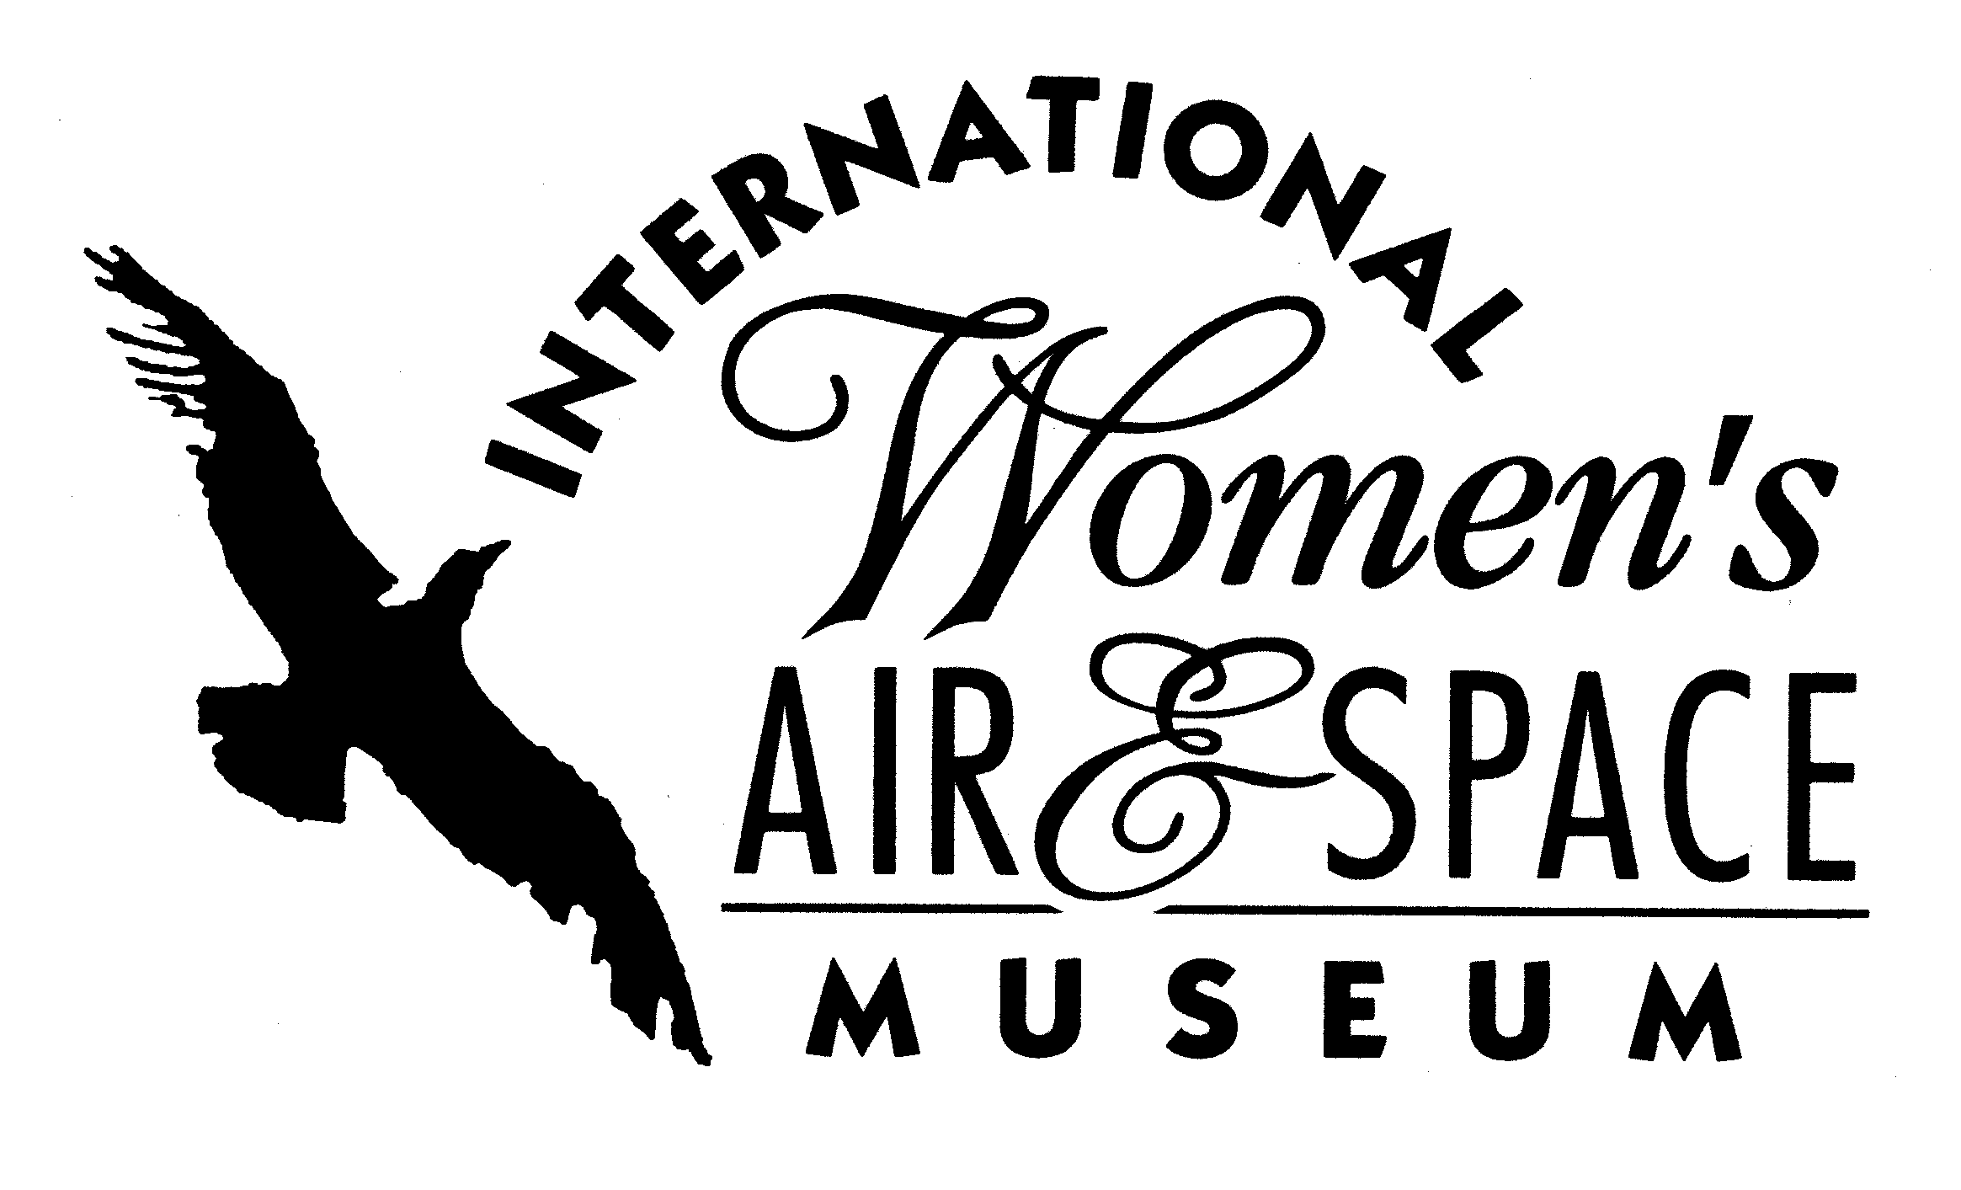

FOR IMMEDIATE RELEASE
September 26, 2006
Contact: Toni Mullee
216-623-1111
440-655-1514 (cell)
tmullee@iwasm.org
www.iwasm.org

INTERNATIONAL WOMEN’S AIR & SPACE MUSEUM TO SPONSOR CAREER SHADOWING DAY

The International Women’s Air & Space Museum (IWASM) is sponsoring Cleared for Liftoff Career Shadowing Day on Tuesday, October 17, 2006. The event, made possible by a generous grant from the Alcoa Foundation and part of the museum’s Cleared For Liftoff educational programming, pairs girls in grades 9-12 with women in science, technology, engineering and mathematics careers. The students will spend a day in the workplace with volunteer mentors learning about the career opportunities for those with an interest in science and mathematics. High school counselors in Northeast Ohio are matching students to mentors based upon their academic interests.
Participating organizations include NASA Glenn Research Center, the FAA, Nordson Corporation, Parker Hannifin, Crane Aerospace and Goodrich.
According to the National Science Foundation, women occupy less than one quarter of the science and engineering jobs in government and the private sector. The balance is slowly changing as women are increasingly earning more science degrees than they were a decade ago. But many experts say that there simply aren’t enough students (both boys and girls) aiming for science careers to fill future science and engineering jobs. Introducing girls to science and math careers early is an important step in the effort to increase number of women in these fields.
-more-

IWASM CAREER SHADOWING DAY OCTOBER 17, 2006 – p.2

“This is a wonderful opportunity for female students considering careers in science and technology to experience a day-in-the-life with women currently in these fields,” said Toni Mullee, the museum’s Executive Director.
The International Women’s Air & Space Museum focuses its educational programming on promotion of careers in science, technology, engineering and mathematics. Plans for 2007 include a mother-daughter career exploration day and STEM camp for middle school students.
The International Women’s Air & Space Museum is located in the terminal building of Burke Lakefront Airport. Museum admission is free and exhibits are open during regular airport hours, 8:00 am-8:00 pm daily. The Fay Gillis Wells Research Center and Gift Shop are open 10:00 am-4:00 pm, Monday through Friday. For more information call (216) 623-1111 or visit us on the web at www.iwasm.org.

###

