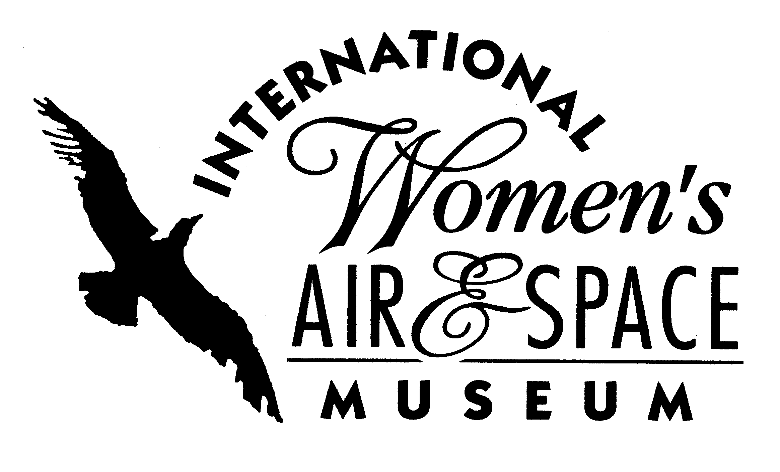
FOR IMMEDIATE RELEASE
August 15, 2007
Contact: Toni Mullee
216-623-1111
440-655-1514 (cell)
tmullee@iwasm.org
www.iwasm.org

Pre-Air Show Party Set for Friday, August 31, 2007
INTERNATIONAL WOMEN’S AIR & SPACE MUSEUM TO HOST “CORKS IN THE CONCOURSE” PRE-AIR SHOW PARTY

The International Women’s Air & Space Museum is hosting a wine tasting event on Friday, August 31, 2007, from 6:00 pm – 10:00 pm. The party, held on the eve of the Cleveland National Air Show, is a fundraiser for the museum. “Corks in the Concourse” will be held at the Burke Lakefront Airport terminal building, among the museum’s exhibits. The evening includes wine tastings from American wineries, hors d’oeuvres, a silent auction and a live raffle. Several Cleveland National Air Show performers will be on hand to mingle with guests.
The museum celebrates the arrival of the United States Air Force Thunderbirds and their two female pilots to Cleveland by featuring U.S. wineries. Wineries participating in this year’s event include: New York’s Niagara Landing Wine Cellars; Ohio’s Farinacci Winery and Debonné Vineyards; California’s Michael Pozzan Winery, Howling Wolf, Oak Grove, and Norman Vineyards; Washington’s Desert Wind Vineyards and Avery Lane; Oregon’s Duck Pond Cellars.
Julie Clark, famed aerobatic pilot, and her crew, will be on hand to talk with party guests. Clark, a pilot for more than 38 years and a retired Northwest Airlines Captain, has been a professional aerobatic air show pilot for over 27 years. Her unique and patriotic show will be a highlight at this year’s Cleveland National Air Show.
Silent auction items include a blimp ride on the Spirit of Goodyear, two round-trip tickets from Youngstown to Orlando on Allegiant Air, and a hot air balloon ride for two. Many Northeast Ohio organizations have donated items to this year’s silent auction and live raffle.

CORKS IN THE CONCOURSE AUGUST 31, 2007 – p.2

Saab, who will have two vehicles on display that evening, sponsors this year’s event. Party guests will be invited to take a test drive at a local Saab dealership and for each test drive a donation will be made to the museum.
Tickets for the event are $50 for museum members and $55 for non-members. A designated driver ticket is available for only $30.

The International Women’s Air & Space Museum is located in the Burke Lakefront Airport, 1501 North Marginal Rd. Museum admission is free and exhibits are open 8:00 am-8:00 pm daily. The Fay Gillis Wells Research Center and Gift Shop are open Monday through Friday from 10:00 am to 4:00 pm. Call (216) 623-1111 for more information or visit us on the web at www.iwasm.org.
###

