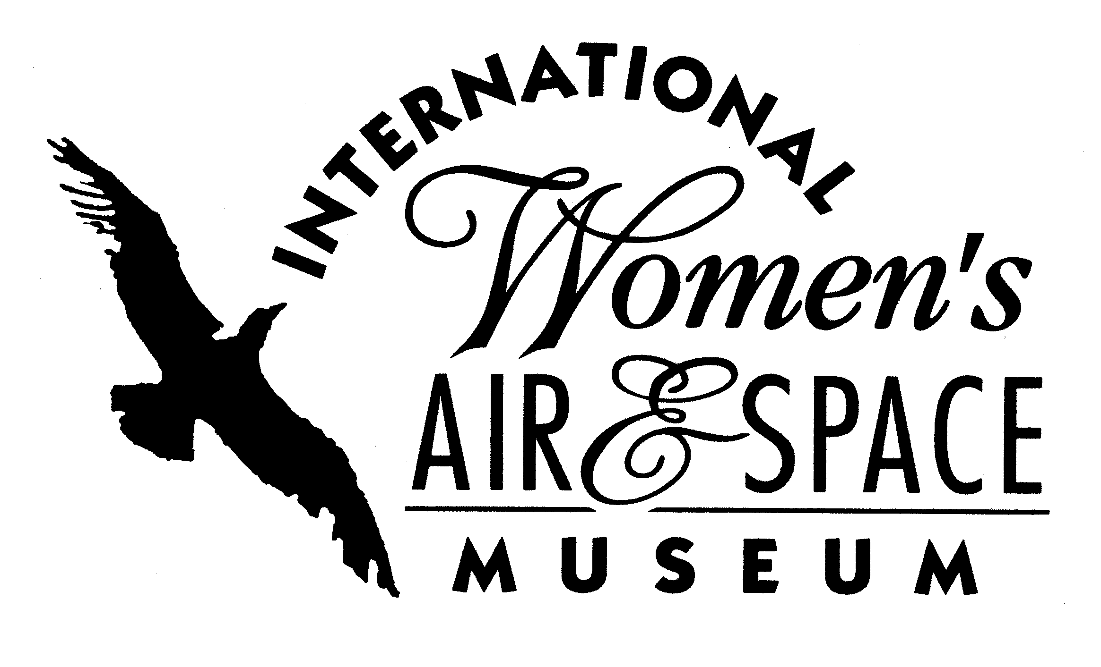
FOR IMMEDIATE RELEASE
February 10, 2010
Contact: Toni Mullee
216-623-1111
440-655-1514 (cell)
tmullee@iwasm.org
www.iwasm.org

Free Family Day Honoring 100 Years of American Women in Flight, Saturday March 13, 2010
INTERNATIONAL WOMEN’S AIR & SPACE MUSEUM TO HOST ANNUAL EVENT IN CELEBRATION OF WOMEN’S HISTORY MONTH

In September 1910, Blanche Stuart Scott became the first American woman to pilot an airplane. On Saturday, March 13, 2010 the International Women’s Air & Space Museum will celebrate her achievements and 100 years of American women in flight with the museum’s fifth annual free family day. The event will take place from 10:00 am – 4:00 pm. Parking is available in the Burke Lakefront Airport terminal municipal parking lot.
The museum will be celebrating Women’s History Month throughout the day with the help of several area organizations. Free activities will be provided by NASA, the Children’s Museum of Cleveland, and the USO. The museum will be giving visitors a sneak peek at its new Aviation Education Center, scheduled to open later this spring with hands-on aviation activities. Also scheduled that day is a demonstration by the Cleveland Hopkins International Airport Aircraft Rescue & Firefighters, planetarium shows, and a military encampment with an exhibit on women in the armed forces. The museum is partnering with the USO to offer visitors an opportunity to make cards for troops overseas throughout the day. Students from Beaumont School will be on hand with activities and to perform as famous women in aviation, including Blanche Stuart Scott. Families and youth groups are encouraged to attend this free special event.
-more-

IWASM FAMILY DAY, SATURDAY, MARCH 13, 2010 – p.2

The public celebration of women's history in this country began in 1978 as "Women's History Week" in Sonoma County, California. The week including March 8, International Women's Day, was selected. In 1981, Sen. Orrin Hatch (R-Utah) and Rep. Barbara Mikulski (D-Md.) co-sponsored a joint Congressional resolution proclaiming a national Women's History Week. In 1987, Congress expanded the celebration to a month, and March was declared Women's History Month.
The International Women’s Air & Space Museum is located in the Burke Lakefront Airport terminal building, 1501 N. Marginal Road. Museum admission is free and exhibits are open 8:00 am – 8:00 pm daily. The Fay Gillis Wells Research Center and Gift Shop are open 10:00 am to 4:00 pm. Monday through Saturday. Call (216) 623-1111 for more information or visit us on the web at www.iwasm.org.

###

