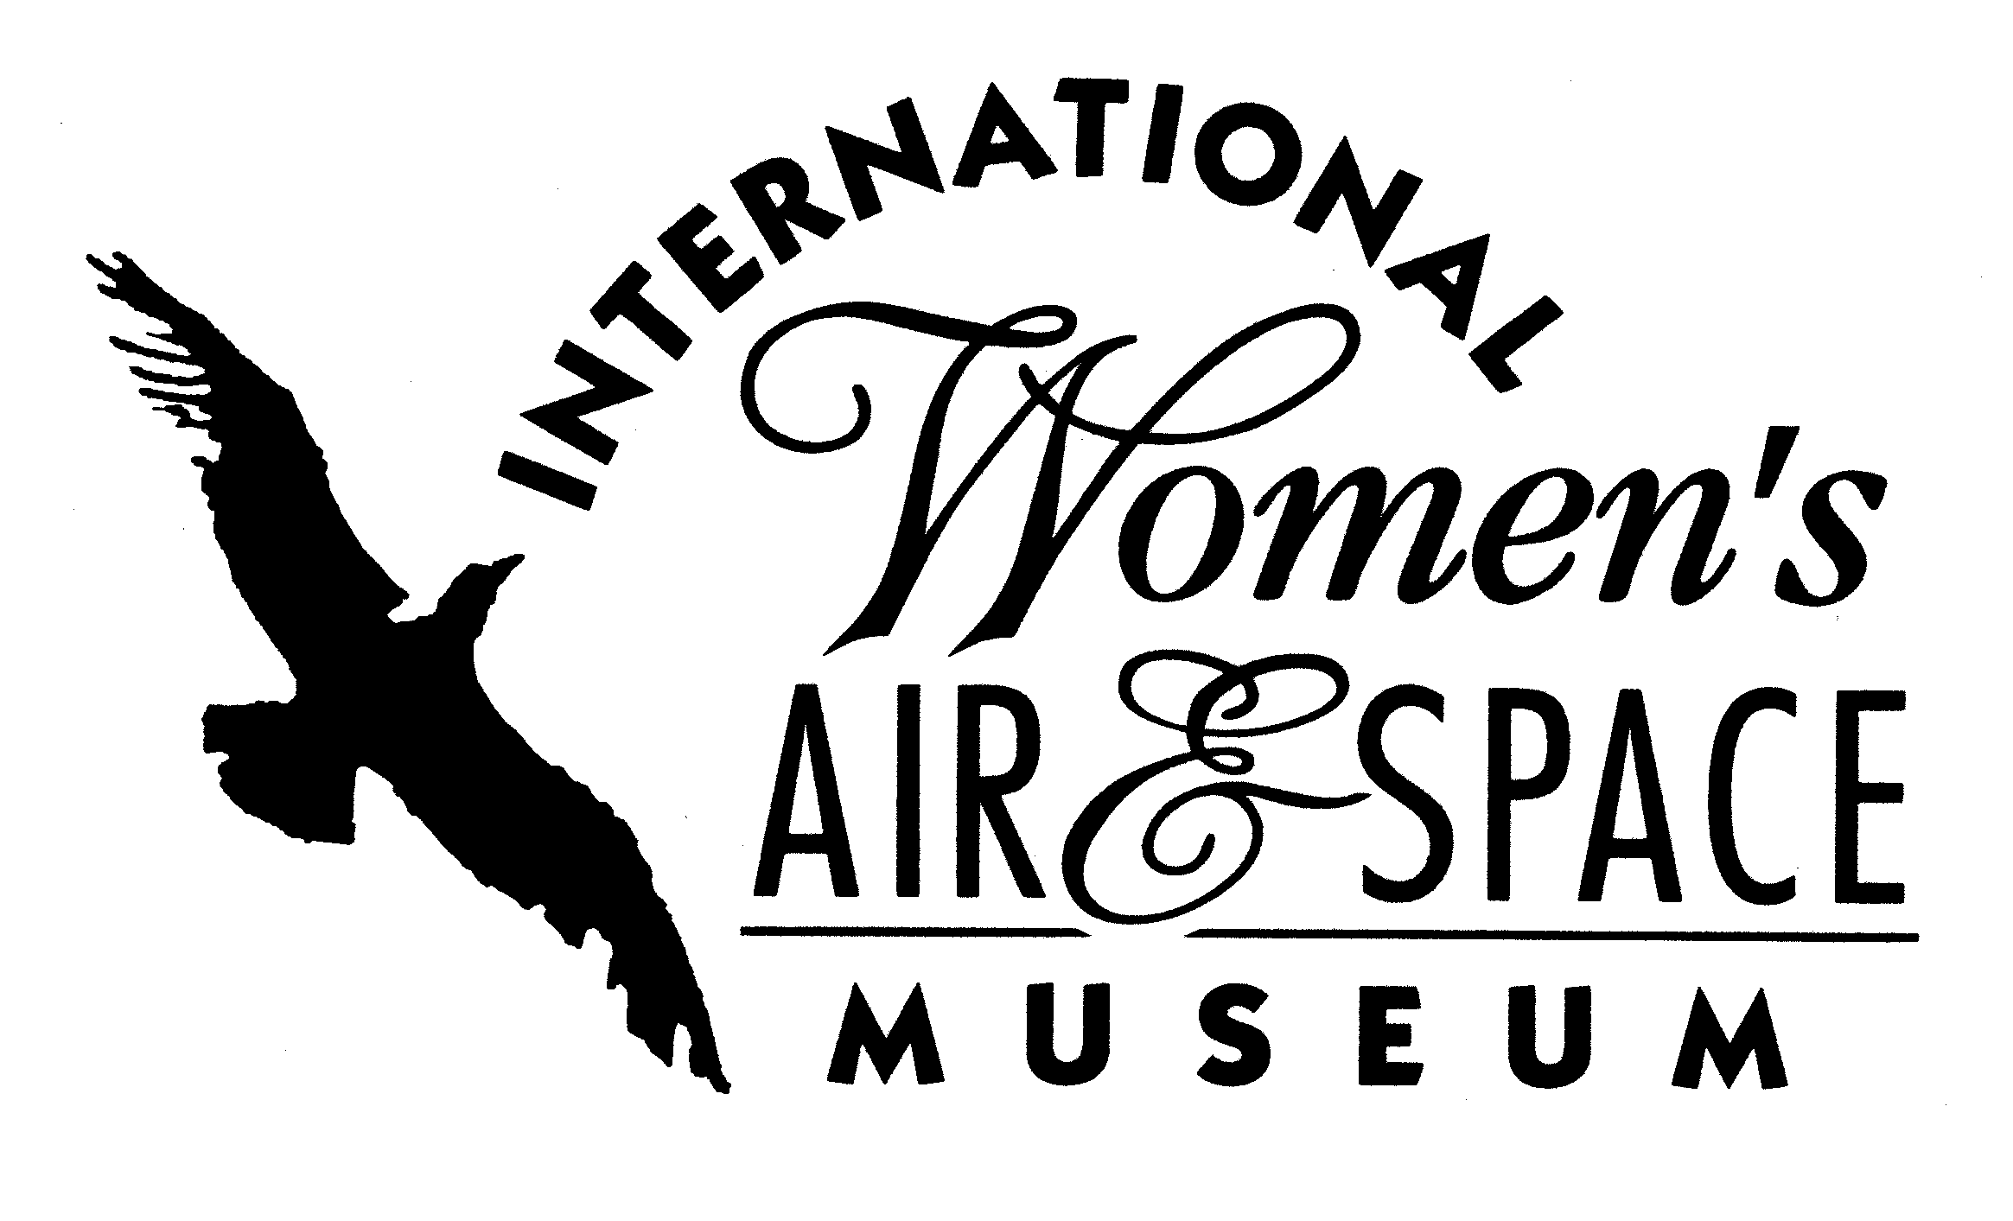

FOR IMMEDIATE RELEASE
October 1, 2007
Contact: Toni Mullee
216-623-1111
440-655-1514 (cell)
tmullee@iwasm.org
www.iwasm.org

INTERNATIONAL WOMEN’S AIR AND SPACE MUSEUM PATCH TO FLY ON BOARD NEXT SPACE SHUTTLE MISSION

NASA has approved a request from the International Women’s Air & Space Museum (IWASM) to fly a museum patch on this month’s space shuttle mission to the International Space Station. Retired Air Force Col. Pamela Melroy will command STS-120 Discovery, which is scheduled to launch October 23, 2007. Melroy is the second woman to command a shuttle. She was the pilot of STS-92 in 2000 and the pilot of STS-112 in 2002. The IWASM patch will be flying aboard Discovery in order to ensure that the historical significance of only the second woman shuttle commander can inspire future generations of women explorers.
The 14-day mission will launch an Italian-built U.S. multi-port module to the station. It will also carry out a crew change for the space station. Another woman astronaut, Stephanie Wilson, will be making her second flight into space on that mission. She flew in 2006 on STS-121.
The International Women’s Air & Space Museum preserves the history of women in aviation and space by documenting their past, present and future contributions. Through educational programming IWASM encourages girls to consider careers in science, technology, engineering and mathematics. The museum has an exhibit dedicated to every woman who has flown in space, from Valentina Tereshkova, the first woman in space, to today’s astronauts.
-more-

MUSEUM PATCH TO FLY ABOARD SPACE SHUTTLE DISCOVERY – p.2

“Because of the historical significance of this mission, we are very proud that the patch will be going up into space on Discovery. Commander Melroy is an inspiration to girls interested in aviation and space,” said Toni Mullee, the museum’s executive director. Once the patch returns from space it will be prominently displayed in the museum.
Museum patches can be purchased at the IWASM gift shop and online at www.iwasm.org.

The International Women’s Air & Space Museum is located in the Burke Lakefront Airport terminal building, 1501 N. Marginal Road, Cleveland, OH. Museum admission is free and exhibits are open 8:00 am – 8:00 pm daily. The Fay Gillis Wells Research Center and Gift Shop are open 10:00 am – 4:00 pm Monday through Friday and by appointment. Call (216) 623-1111 for more information or visit us on the web at www.iwasm.org

###

