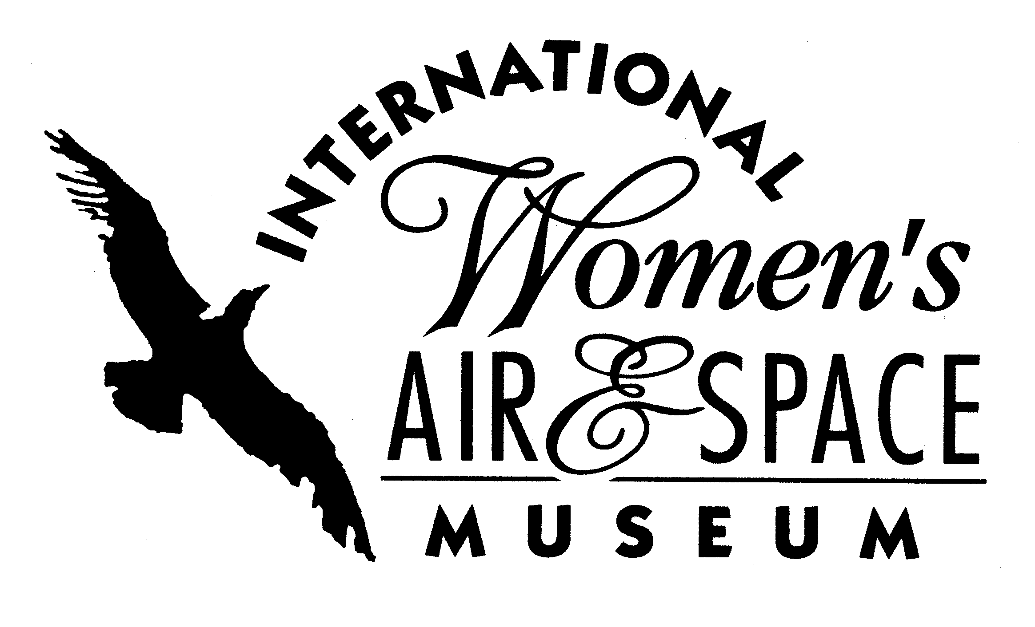

FOR IMMEDIATE RELEASE
November 21, 2008
Contact: Toni Mullee
216-623-1111
440-655-1514 (cell)
tmullee@iwasm.org
www.iwasm.org
Historical Cards Feature Several Cleveland- Area Women in Aviation and Space
INTERNATIONAL WOMEN’S AIR & SPACE MUSEUM RELEASES
NEW DECK OF HISTORICAL PLAYING CARDS

The International Women’s Air & Space Museum (IWASM) has created a second collectible deck of playing cards celebrating the achievements of women in aviation and space. The museum is now selling the cards in the museum’s gift shop and online store. The deck includes the standard 52 cards plus 3 wild cards. Each card face includes a photo and historical fact about a woman in aviation or space.
Several area women are featured in this year’s deck. Blanche Noyes was a native of Cleveland. She was one of the first women in Ohio to earn a pilot’s license and participated in the 1929 National Women’s Air Derby, part of the Cleveland National Air Races. Noyes took John D. Rockefeller on his only plane ride, when he was in his 90’s. Louise Vamos was a pioneer aviator in the 1930’s. She was the first female commercial pilot in Cleveland. Libby Mele was a lifelong resident of Willoughby who was one of the first female air traffic controllers in the U.S. Helen Sammon served as a hostess at the Cleveland National Air Races and earned her pilot’s license in 1950. She participated in many air races and was a member of the Civil Air Patrol. Sammon has traveled twice to China as a representative of the International Women’s Air & Space Museum and is on the museum’s board of trustees. Pat Brady is a traffic reporter
-more-

HISTORICAL DECK OF PLAYING CARDS FEATURES LOCAL AVIATRIXES – p.2
for WMMS radio and Fox 8. She is a member of the Whirly Girls, a women’s helicopter pilot organization. Judith Resnik was one of the first six women astronauts accepted into the NASA astronaut corps in 1978. She was the second woman in space and died in the Challenger disaster in 1986. Resnik was a native of Akron, Ohio.
The first deck of cards was introduced in the fall of 2007 and sold out quickly. None of the women featured on the first deck are repeated in this new project. Many of the photos used to create the deck are from the IWASM archives. Famous women aviators on this deck of cards include Anne Morrow Lindbergh, Charles Lindbergh’s wife and co-pilot, Patty Wagstaff, the first female aerobatics champion, and Nicole Malachowski, the first female Thunderbird pilot. The deck features a number of women astronauts and more international pilots. Astronauts in the deck include Resnik, Sally Ride, Peggy Whitson and Pam Melroy. “There was a tremendous amount of excitement among aviation enthusiasts for a second deck of cards. This gives us the opportunity to highlight more incredible women in aviation and space,” said Executive Director, Toni Mullee. “The first deck was a huge success and sold out in just a few months so we are confident that this deck will be a hit.”
The project is a fundraiser for the museum. Card faces were sponsored by individuals and organizations interested in supporting the project as well as family members of many of the women featured. One thousand decks have been produced and sell for $10 per deck at the museum gift shop. The cards can also be ordered by telephone (216-623-1111) or through the museum’s online store (www.iwasm.org).
The International Women’s Air & Space Museum is located in the Burke Lakefront Airport terminal building, 1501 N. Marginal Road, Cleveland, OH. Museum admission is free and exhibits are open 8:00 am – 8:00 pm daily. The Fay Gillis Wells Research Center and Gift Shop are open 10:00 am – 4:00 pm Monday through Friday and by appointment. Call (216) 623-1111 for more information or visit us on the web at www.iwasm.org.

For images of playing cards visit www.iwasm.org/playingcards
###

