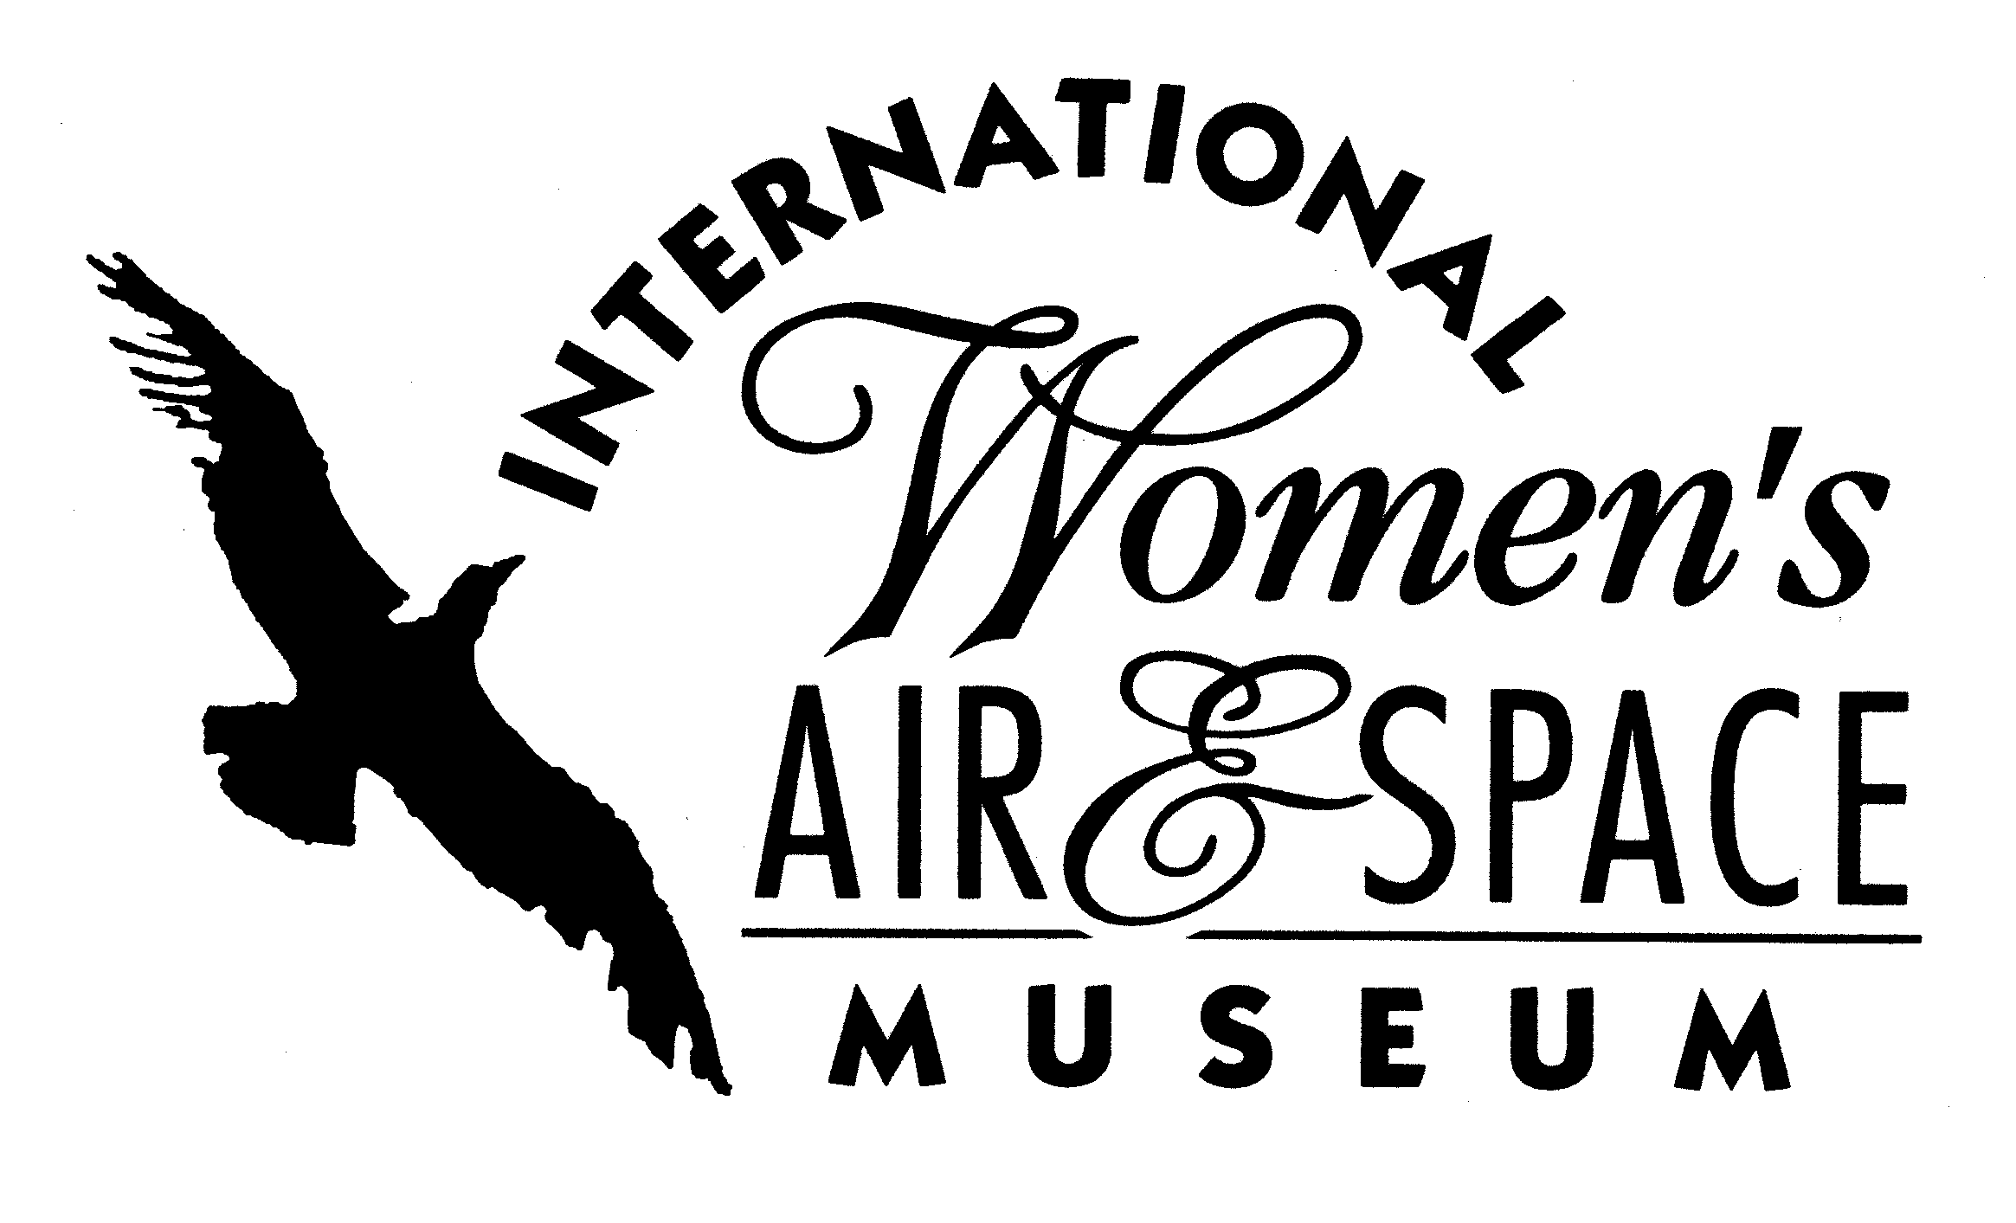

FOR IMMEDIATE RELEASE
November 27, 2007
Contact: Toni Mullee
216-623-1111
440-655-1514 (cell)
tmullee@iwasm.org
www.iwasm.org

INTERNATIONAL WOMEN’S AIR & SPACE MUSEUM RELEASES DECK OF HISTORICAL PLAYING CARDS, OPENS NEW EXHIBIT

The International Women’s Air & Space Museum (IWASM) has introduced a collectible deck of playing cards celebrating the achievements of women in aviation and space. Many of the photos used to create the deck are from the IWASM archives. Famous women aviators on the cards include Amelia Earhart, Bessie Coleman, and Eileen Collins. Several WASPs are featured in the deck as are many women pioneers of aviation. “This was a fun project to complete,” said Executive Director, Toni Mullee. “The most difficult part of it was condensing these women’s achievements to 60 characters or less so they would fit on the cards.” The museum already has plans for a second deck to include the many women that they were unable to include in the cards the first time around.
The deck includes the standard 52 cards plus 3 wild cards. Each card face includes a photo and historical fact about the subject. Card faces were sponsored by individuals and organizations interested in supporting the project as well as family members of some of the earliest women aviation pioneers. One thousand decks have been produced and sell for $10 per deck at the museum gift shop. The cards can also be ordered by telephone (216-623-1111) or through the museum’s online store (www.iwasm.org).
-more-

HISTORICAL PLAYING CARDS, NEW EXHIBIT – p.2

To celebrate the completion of the project, IWASM’s new temporary exhibit, In the Cards, will feature artifacts of some of the most famous women included in the deck. Items from Amelia Earhart, Eileen Collins and record setters Louise Thaden and Jerrie Mock will be spotlighted in the exhibit, which will be located in the west concourse of Burke Lakefront Airport. The exhibit will be open December 5, 2007 through February 24, 2008.

The International Women’s Air & Space Museum is located in the Burke Lakefront Airport terminal building, 1501 N. Marginal Road, Cleveland, OH. Museum admission is free and exhibits are open 8:00 am – 8:00 pm daily. The Fay Gillis Wells Research Center and Gift Shop are open 10:00 am – 4:00 pm Monday through Friday and by appointment. Call (216) 623-1111 for more information or visit us on the web at www.iwasm.org.

###

