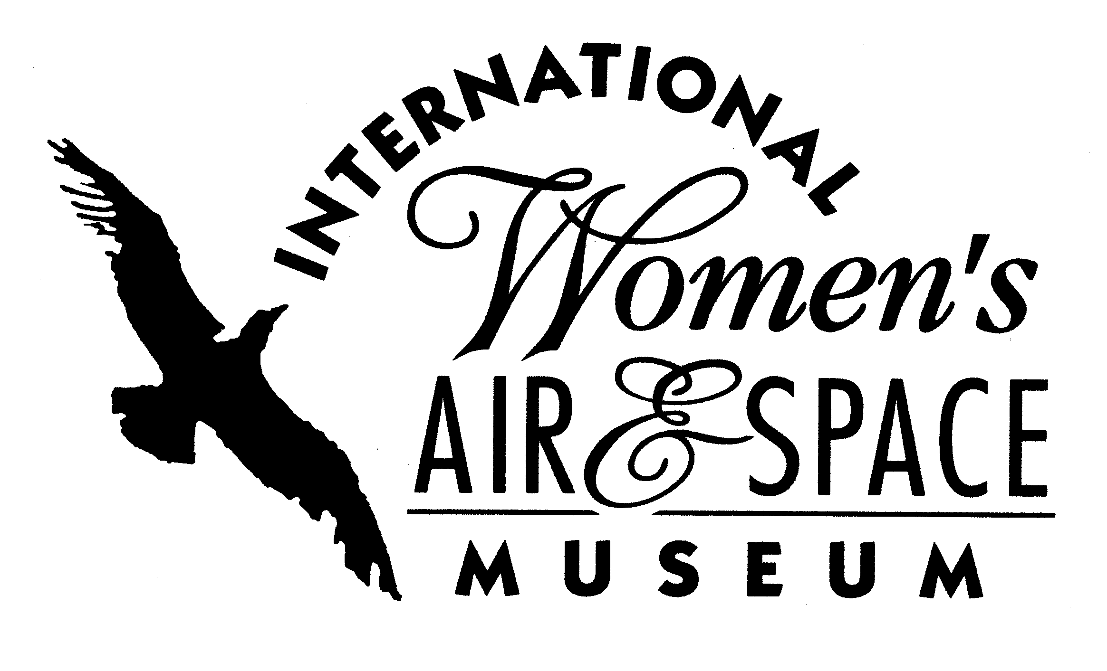
FOR IMMEDIATE RELEASE
June 10, 2008
Contact: Toni Mullee
216-623-1111
440-655-1514 (cell)
tmullee@iwasm.org
www.iwasm.org

INTERNATIONAL WOMEN’S AIR & SPACE MUSEUM HONORS
SALLY RIDE WITH EXHIBIT

The International Women’s Air & Space Museum (IWASM) is paying tribute to Sally Ride, the first American woman in space, with a new exhibit now open on the 25th anniversary of her historic flight into space on June 18, 1983. This exhibit, located in the west concourse of the Burke Lakefront Airport terminal building, includes biographical information, memorabilia from Kennedy Space Center, photos and crew & flight information. The exhibit will be open through August 15, 2008. Museum admission is free.
In the mid-1970’s Sally Ride was working on her PhD at Stanford University when she saw a notice that NASA was looking for scientists interested in becoming mission specialists. NASA was encouraging women to apply. Ride was one of 8,369 people (including 1,000 women) to apply to NASA for the astronaut class of 1978. From that original group of applicants, 35 were chosen and joined NASA as astronaut trainees. Ride and five other women were among them.
Ride was selected as a mission specialist on STS-7, aboard the space shuttle Challenger. On June 18, 1983, Sally Ride and her four other crewmates took off from Cape Canaveral at 7:33 am. The mission lasted six days, two hours and twenty-three minutes. Ride was responsible for deploying two satellites into space and participating in forty different experiments. Upon completion of a successful mission, the space shuttle landed at Edwards Air Force Base on June 24, 1983 after bad weather caused a Florida landing to be scrubbed.
-more-

NEW SALLY RIDE EXHIBIT AT IWASM – p.2

A little over a year later Ride took a second successful shuttle trip. In 1986, after the Challenger tragedy, Ride was part of a special commission that was responsible for investigating the accident and suggesting changes to the shuttle program. She was once again called upon to serve her country as a member of the commission that investigated the Columbia disaster. She was the only person to serve on both committees. Ride is currently the president and CEO of Sally Ride Science.
IWASM’s mission is to preserve the history of women in aviation and space by documenting their past, present and future contributions. The Fay Gillis Wells Research Center houses an extensive collection of information on women in these fields. The museum has several permanent exhibits documenting the role of women in space, including the Women in Space: Wall of Fame, and Living & Working in Space.

The International Women’s Air & Space Museum is located in the Burke Lakefront Airport terminal building, 1501 N. Marginal Road. Museum admission is free and exhibits are open 8:00 am –7:00 pm daily. The Fay Gillis Wells Research Center and Gift Shop are open 10:00 am – 4:00 pm Monday through Saturday. Call (216) 623-1111 for more information or visit us on the web at www.iwasm.org.

###

