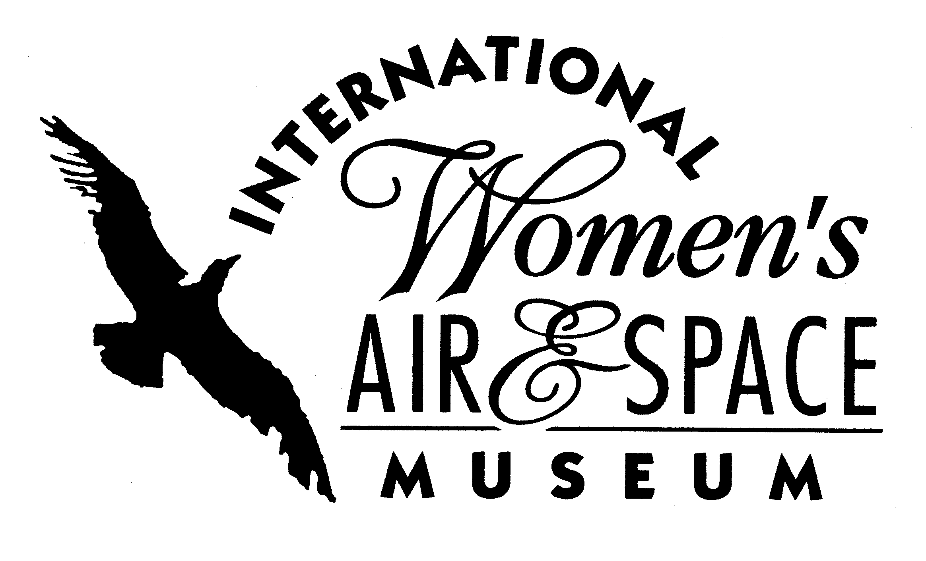

FOR IMMEDIATE RELEASE
May 26, 2006
Contact: Toni Mullee
216-623-1111
440-655-1514 (cell)
tmullee@iwasm.org
www.iwasm.org

Cleared for Liftoff Camp to focus on science and technology
CLEARED FOR LIFTOFF CAMP SCHEDULED FOR JULY 10-14, 2006 AT LAKELAND COMMUNITY COLLEGE CAMPUS OPEN TO STUDENTS

The International Women’s Air & Space Museum (IWASM) in conjunction with the Lakeland Community College Tech Prep Consortium and Ohio’s Career Development Program is offering students entering the 9th grade the opportunity to participate in an interactive camp designed to excite participants and promote careers in science, technology, engineering and mathematics. The camp will be held July 10-14, 2006 at the Lakeland Community College Campus. There are two sessions available – a morning session that runs from 9:00 am – 11:30 am and an afternoon session that runs from 1:00 pm to 3:30 pm. Cost for either session is $50 for the week.
Students enrolled in the camp will sample a variety of hands-on activities. Each day the camp activity will focus on a different aspect of technology. Students will design their own house using Computer Aided Drafting and explore health technology careers by practicing surgical techniques and taking DNA swabs. Each participant will also design and make a school medallion in Manufacturing and Machining . Students will make their own website and game as they explore Information Technology. The week will end with a luncheon for participants and their parents.

CLEARED FOR LIFTOFF CAMP, JULY 10-14, 2006 – p.2

Students interested in the camp can go to www.clearedforliftoff.org or www.iwasm.org for the registration and liability release forms, or contact Kathleen Radigan at 440-942-1742, or the IWASM office at 216-623-1111. Cost for the week-long camp is $50 per student. Space is limited and reservations should be received no later than June 16, 2006.

The International Women’s Air & Space Museum is located in the Burke Lakefront Airport, 1501 North Marginal Road. Museum admission is free and exhibits are open 8 a.m. to 8 p.m. daily. The Fay Gillis Wells Research Center and Gift Shop are open 10:00 a.m. to 4:00 p.m. Monday through Friday. Call (216) 623-1111 for more information or visit us on the web at www.iwasm.org.
###

